PAPER: What makes a good ontology? A case-study in fine-grained knowledge reuse

Our study shows that there is no statistically significant information to assure that these measures are able to identify the best semantic content in the context of this task. However, we have detected some tendencies which may show that the “best” ontologies are generally those that are more populated and have higher values of depth and breadth variance in their structure.

LINKS:

* <http://citeseerx.ist.psu.edu/viewdoc/download?doi=10.1.1.157.5878&rep=rep1&type=pdf>
* <https://github.com/roomylee/awesome-relation-extraction#research-trends-and-surveys>
* <https://www.aclweb.org/anthology/W16-3005>
* <http://www.mkbergman.com/908/a-new-methodology-for-building-lightweight-domain-ontologies/>

Quality measures for ontologies

Paper: A quality measure for automatic ontology evaluation and improvement

We can evaluate our relation using recall, precision and F1 score.

<https://www.aclweb.org/anthology/W16-3005>

Making an interface for this purpose. We need to identify which entities are important or not. For this purpose, we need human level evaluation in order to get useful entities.

Relation Evaluation

Entity Evaluation

Evaluation of Relations between entities

Evaluation of ontologies

Evaluation

Dependency Parsing

It provides basic dependencies and/or enhanced dependencies

Convert json to RDF by using any library. There are a lot of libraries on web.

It gives binary relations. That can be converted to json format using annotate function.

Json format

WEB Crawler

CoreNLP

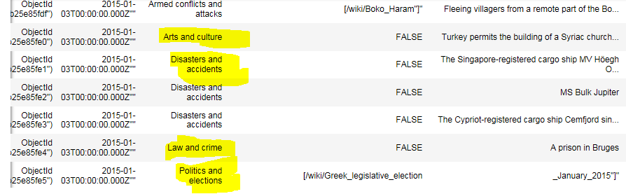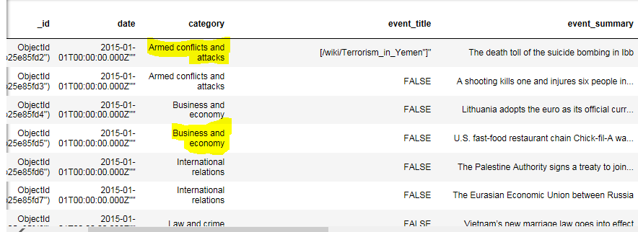

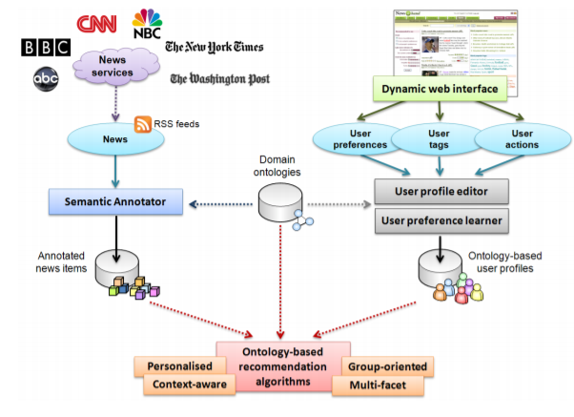

 There are many ways to categorize [ontologies](http://techwiki.openstructs.org/index.php/Ontology_Concept).

* One dimension is between upper level and mid- and lower- (or domain-) level.
* Another is between reference or subject (domain) ontologies. [Upper-level ontologies](http://en.wikipedia.org/wiki/Upper_ontology_%28computer_science%29) [[2]](http://www.mkbergman.com/908/a-new-methodology-for-building-lightweight-domain-ontologies/#obp2) tend to be encompassing, abstract and inclusive ways to split or organize all “things”.
* Reference ontologies tend to be cross-cutting such as ones that describe people and their interests (*e.g.*, [FOAF](http://techwiki.openstructs.org/index.php/FOAF_Concept)), reference subject concepts (*e.g.*, [UMBEL](http://techwiki.openstructs.org/index.php/UMBEL_Concept)), bibliographies and citations (*e.g.*, [BIBO](http://en.wikipedia.org/wiki/Bibliographic_Ontology)), projects (*e.g.*, [DOAP](http://en.wikipedia.org/wiki/DOAP)), simple knowledge structures (*e.g.*, [SKOS](http://techwiki.openstructs.org/index.php/SKOS_Concept)), social networks and activities (*e.g.*, [SIOC](http://en.wikipedia.org/wiki/Semantically-Interlinked_Online_Communities)), and so forth.
* The focus here is on domain ontologies, which are descriptions of particular subject or domain areas. Domain ontologies are the “world views” by which organizations, communities or enterprises describe the concepts in their domain, the relationships between those concepts, and the instances or individuals that are the actual things that populate that structure. Thus, domain ontologies are the basic bread-and-butter descriptive structures for real-world applications of ontologies.

Light weight ontologies/ Good ontologies

Correct identification of domain

Accuracy of naming for entities and relationships

Reuse of existing vocabularies

Linked Open Vocabularies (LOV): a gateway to reusable semantic vocabularies on the Web

<http://www.semantic-web-journal.net/system/files/swj1127.pdf>

<http://www.pilod.nl/wiki/Reuse_of_standard_vocabularies>